Lab 4 – Analysing Website using Burp Suite

**Task 1: Capturing request and response.**

Capture request and response while signing up and signing in into your website. Signup and sign in using your name as username. Try with both correct and incorrect credentials.

Incorrect credentials

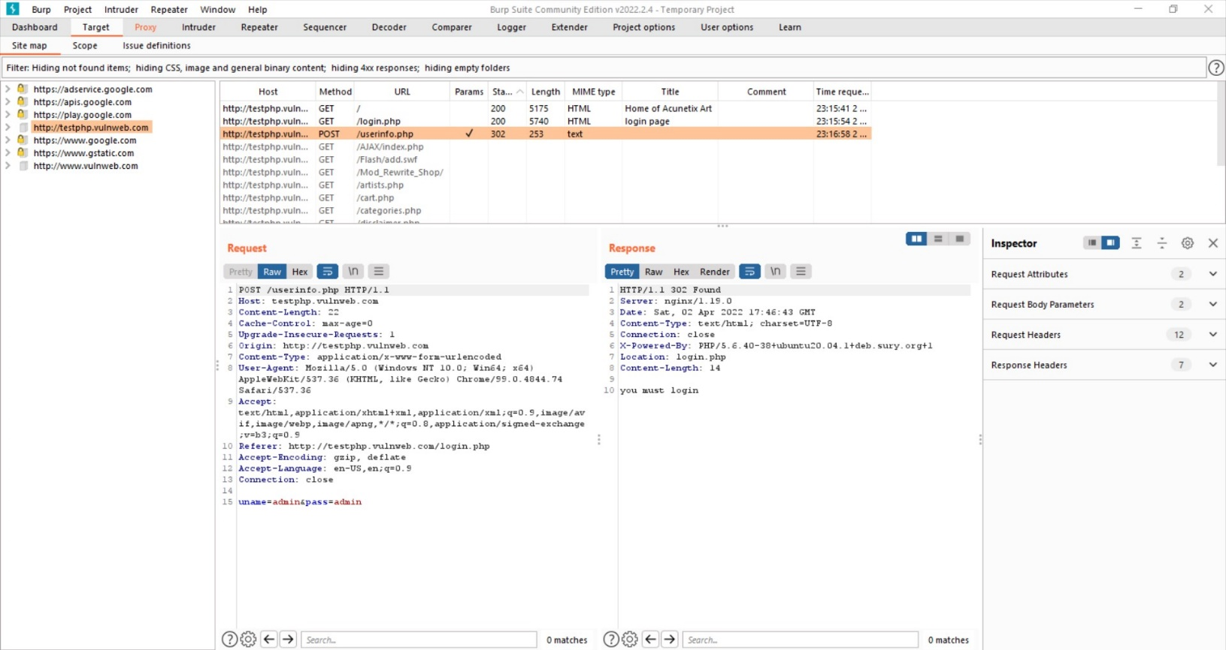

Correct credentials

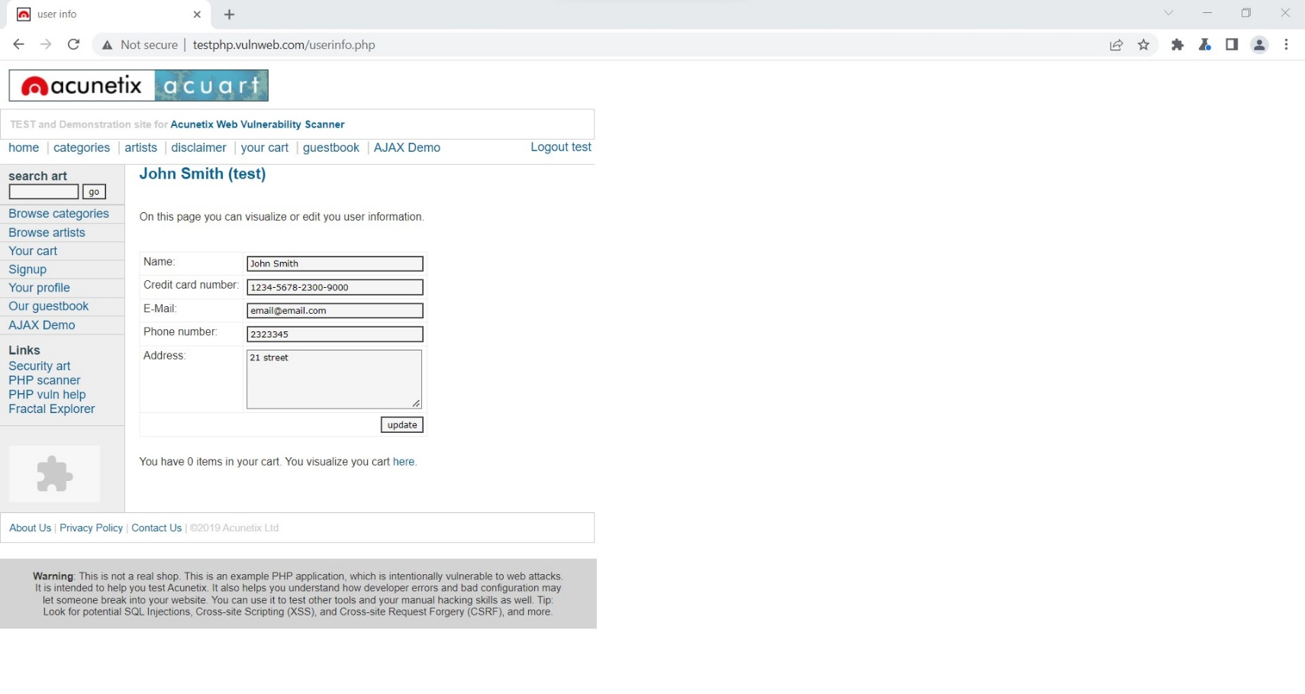

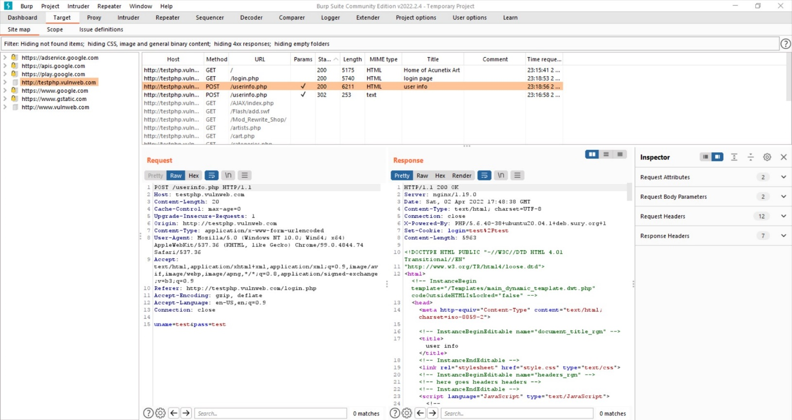

**Task 2: Use of repeater.**

Repeat the requests captured in Task 1 and see what response is coming from server.

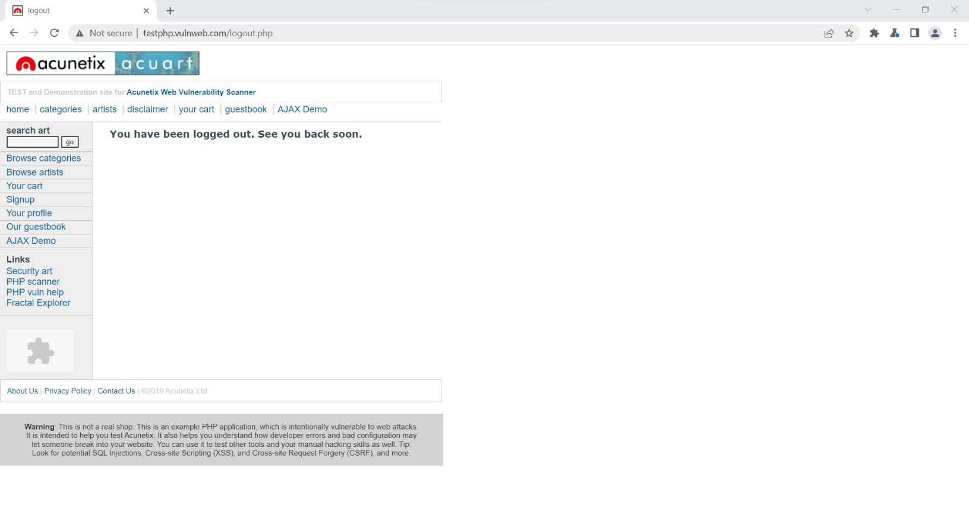

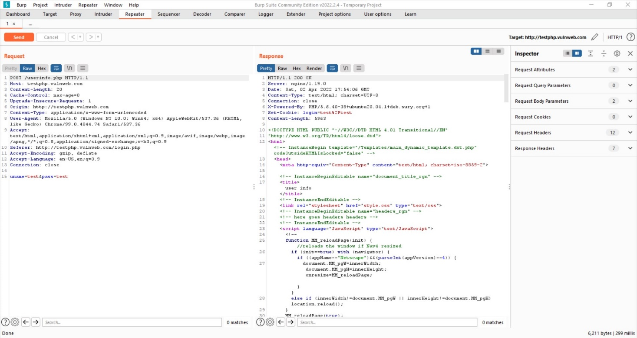

**Task 3: Brute force.**

Send a request to intruder and create 2 different payloads for usernames and passwords. Try cluster bomb attack type to find valid credential for that website.

